**初始结构**

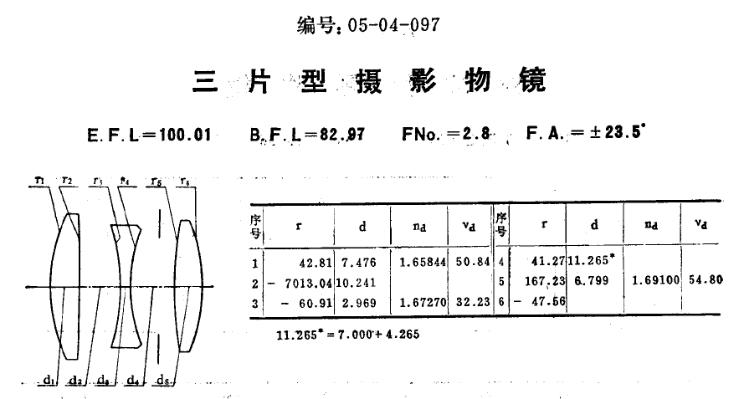

**以下未标明摄影距离的均为5m摄影距离情况下**

**二维轮廓图**

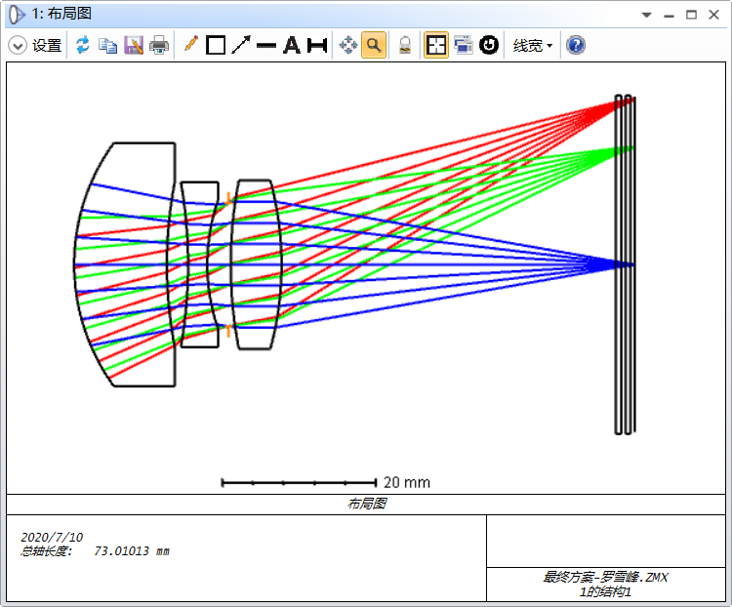

图1 设计结果二维轮廓图

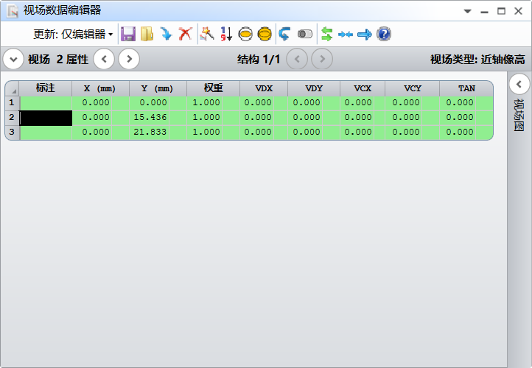

图2 全视场拦光0%

**成像质量**

三色球差曲线及数据：

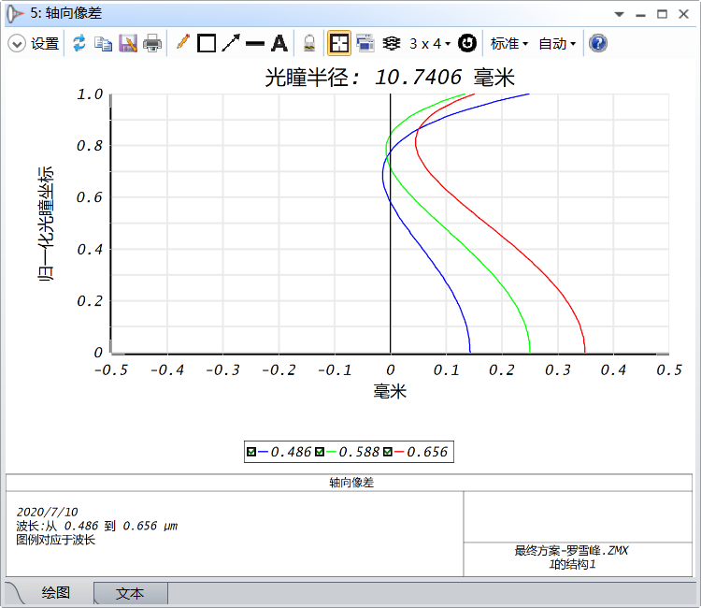

图3 三色球差曲线

三色球差数据如下：

轴向像差数据列表

文件 : F:\ZJU\光学系统设计\搞事\最终方案-罗雪峰.ZMX

题目:

日期 : 2020/7/10

单位是毫米.

Rel. 光瞳 0.4861 0.5876 0.6563

0.0000 1.432E-01 2.506E-01 3.491E-01

0.0100 1.432E-01 2.505E-01 3.491E-01

0.0200 1.430E-01 2.503E-01 3.488E-01

0.0300 1.427E-01 2.499E-01 3.484E-01

0.0400 1.422E-01 2.494E-01 3.478E-01

0.0500 1.417E-01 2.487E-01 3.471E-01

0.0600 1.410E-01 2.478E-01 3.461E-01

0.0700 1.402E-01 2.468E-01 3.451E-01

0.0800 1.393E-01 2.456E-01 3.438E-01

0.0900 1.382E-01 2.443E-01 3.424E-01

0.1000 1.371E-01 2.429E-01 3.408E-01

0.1100 1.358E-01 2.412E-01 3.391E-01

0.1200 1.344E-01 2.395E-01 3.372E-01

0.1300 1.329E-01 2.376E-01 3.351E-01

0.1400 1.312E-01 2.355E-01 3.329E-01

0.1500 1.295E-01 2.333E-01 3.305E-01

0.1600 1.277E-01 2.310E-01 3.280E-01

0.1700 1.257E-01 2.285E-01 3.253E-01

0.1800 1.237E-01 2.259E-01 3.225E-01

0.1900 1.215E-01 2.231E-01 3.195E-01

0.2000 1.192E-01 2.202E-01 3.164E-01

0.2100 1.169E-01 2.172E-01 3.131E-01

0.2200 1.144E-01 2.141E-01 3.097E-01

0.2300 1.119E-01 2.108E-01 3.062E-01

0.2400 1.092E-01 2.074E-01 3.025E-01

0.2500 1.065E-01 2.039E-01 2.987E-01

0.2600 1.037E-01 2.002E-01 2.947E-01

0.2700 1.008E-01 1.965E-01 2.907E-01

0.2800 9.788E-02 1.926E-01 2.865E-01

0.2900 9.486E-02 1.886E-01 2.821E-01

0.3000 9.176E-02 1.846E-01 2.777E-01

0.3100 8.860E-02 1.804E-01 2.732E-01

0.3200 8.539E-02 1.761E-01 2.685E-01

0.3300 8.212E-02 1.718E-01 2.637E-01

0.3400 7.880E-02 1.673E-01 2.589E-01

0.3500 7.544E-02 1.628E-01 2.539E-01

0.3600 7.203E-02 1.582E-01 2.488E-01

0.3700 6.860E-02 1.535E-01 2.437E-01

0.3800 6.514E-02 1.487E-01 2.385E-01

0.3900 6.165E-02 1.439E-01 2.332E-01

0.4000 5.815E-02 1.391E-01 2.278E-01

0.4100 5.464E-02 1.342E-01 2.224E-01

0.4200 5.113E-02 1.292E-01 2.169E-01

0.4300 4.762E-02 1.242E-01 2.113E-01

0.4400 4.412E-02 1.192E-01 2.057E-01

0.4500 4.064E-02 1.141E-01 2.001E-01

0.4600 3.718E-02 1.090E-01 1.944E-01

0.4700 3.376E-02 1.039E-01 1.887E-01

0.4800 3.038E-02 9.883E-02 1.830E-01

0.4900 2.704E-02 9.374E-02 1.772E-01

0.5000 2.377E-02 8.865E-02 1.715E-01

0.5100 2.056E-02 8.359E-02 1.657E-01

0.5200 1.742E-02 7.855E-02 1.600E-01

0.5300 1.438E-02 7.355E-02 1.543E-01

0.5400 1.142E-02 6.859E-02 1.486E-01

0.5500 8.574E-03 6.369E-02 1.429E-01

0.5600 5.842E-03 5.885E-02 1.373E-01

0.5700 3.235E-03 5.408E-02 1.317E-01

0.5800 7.660E-04 4.940E-02 1.262E-01

0.5900 -1.554E-03 4.481E-02 1.208E-01

0.6000 -3.713E-03 4.032E-02 1.155E-01

0.6100 -5.698E-03 3.595E-02 1.102E-01

0.6200 -7.497E-03 3.171E-02 1.051E-01

0.6300 -9.096E-03 2.761E-02 1.000E-01

0.6400 -1.048E-02 2.366E-02 9.514E-02

0.6500 -1.164E-02 1.987E-02 9.039E-02

0.6600 -1.256E-02 1.626E-02 8.580E-02

0.6700 -1.322E-02 1.285E-02 8.137E-02

0.6800 -1.361E-02 9.639E-03 7.712E-02

0.6900 -1.370E-02 6.651E-03 7.307E-02

0.7000 -1.350E-02 3.900E-03 6.923E-02

0.7100 -1.297E-02 1.400E-03 6.562E-02

0.7200 -1.209E-02 -8.318E-04 6.225E-02

0.7300 -1.086E-02 -2.778E-03 5.914E-02

0.7400 -9.250E-03 -4.422E-03 5.630E-02

0.7500 -7.240E-03 -5.746E-03 5.375E-02

0.7600 -4.810E-03 -6.730E-03 5.151E-02

0.7700 -1.939E-03 -7.355E-03 4.961E-02

0.7800 1.395E-03 -7.601E-03 4.805E-02

0.7900 5.216E-03 -7.448E-03 4.686E-02

0.8000 9.547E-03 -6.874E-03 4.606E-02

0.8100 1.441E-02 -5.856E-03 4.567E-02

0.8200 1.984E-02 -4.372E-03 4.571E-02

0.8300 2.585E-02 -2.397E-03 4.620E-02

0.8400 3.248E-02 9.375E-05 4.718E-02

0.8500 3.976E-02 3.126E-03 4.866E-02

0.8600 4.770E-02 6.726E-03 5.067E-02

0.8700 5.636E-02 1.092E-02 5.324E-02

0.8800 6.574E-02 1.574E-02 5.640E-02

0.8900 7.590E-02 2.122E-02 6.017E-02

0.9000 8.686E-02 2.738E-02 6.458E-02

0.9100 9.867E-02 3.426E-02 6.966E-02

0.9200 1.114E-01 4.190E-02 7.546E-02

0.9300 1.250E-01 5.032E-02 8.199E-02

0.9400 1.395E-01 5.957E-02 8.930E-02

0.9500 1.551E-01 6.967E-02 9.742E-02

0.9600 1.717E-01 8.068E-02 1.064E-01

0.9700 1.894E-01 9.263E-02 1.163E-01

0.9800 2.082E-01 1.056E-01 1.270E-01

0.9900 2.282E-01 1.195E-01 1.388E-01

1.0000 2.495E-01 1.346E-01 1.516E-01

轴外像差曲线及数据和畸变：

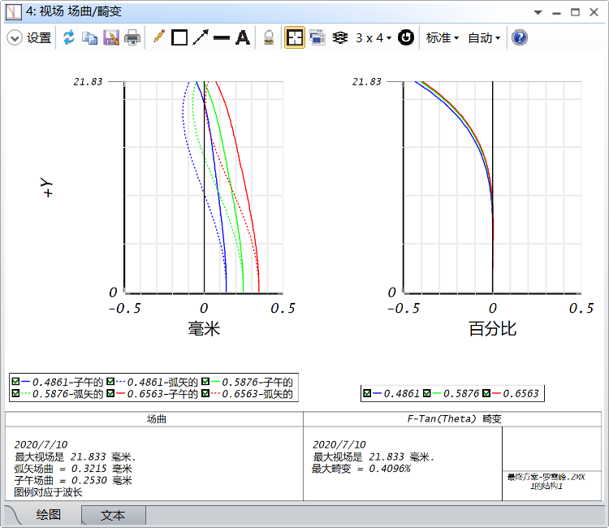

图4 轴外像差曲线和畸变

轴外像差和畸变数据：

场曲数据列表

文件 : F:\ZJU\光学系统设计\搞事\最终方案-罗雪峰.ZMX

题目:

日期 : 2020/7/10

畸变类型: F-Tan(Theta)

位移单位是毫米.

高度单位是毫米.

畸变单位是百分比.

畸变单位是毫米.

最大畸变 = 0.4096%

数据对于波长 : 0.486133 μm.

畸变焦距 = 60.76932

Y 高度 Tan位移 矢高位移 实部高度 参考高度 畸变

0.00000000 0.14321214 0.14321214 0.00000000 0.00000000 0.00000000 %

0.21833000 0.14318181 0.14313611 0.21738855 0.21738839 0.00007542 %

0.43666000 0.14308947 0.14290805 0.43477718 0.43477677 0.00009323 %

0.65499000 0.14293527 0.14252817 0.65216596 0.65216516 0.00012276 %

0.87332000 0.14271944 0.14199679 0.86955497 0.86955354 0.00016363 %

1.09165000 0.14244229 0.14131432 1.08694427 1.08694193 0.00021548 %

1.30998000 0.14210423 0.14048136 1.30433394 1.30433032 0.00027779 %

1.52831000 0.14170575 0.13949857 1.52172403 1.52171870 0.00034992 %

1.74664000 0.14124743 0.13836679 1.73911459 1.73910709 0.00043111 %

1.96497000 0.14072993 0.13708695 1.95650566 1.95649547 0.00052051 %

2.18330000 0.14015401 0.13566012 2.17389728 2.17388386 0.00061711 %

2.40163000 0.13952050 0.13408750 2.39128946 2.39127225 0.00071981 %

2.61996000 0.13883031 0.13237040 2.60868222 2.60866063 0.00082740 %

2.83829000 0.13808443 0.13051026 2.82607554 2.82604902 0.00093854 %

3.05662000 0.13728394 0.12850866 3.04346941 3.04343740 0.00105178 %

3.27495000 0.13642997 0.12636729 3.26086380 3.26082579 0.00116554 %

3.49328000 0.13552374 0.12408797 3.47825863 3.47821418 0.00127814 %

3.71161000 0.13456654 0.12167265 3.69565385 3.69560256 0.00138777 %

3.92994000 0.13355971 0.11912339 3.91304935 3.91299095 0.00149251 %

4.14827000 0.13250468 0.11644240 4.13044502 4.13037933 0.00159031 %

4.36660000 0.13140291 0.11363199 4.34784072 4.34776772 0.00167903 %

4.58493000 0.13025593 0.11069461 4.56523629 4.56515611 0.00175638 %

4.80326000 0.12906533 0.10763284 4.78263153 4.78254449 0.00181997 %

5.02159000 0.12783273 0.10444937 5.00002624 4.99993288 0.00186728 %

5.23992000 0.12655982 0.10114702 5.21742017 5.21732126 0.00189569 %

5.45825000 0.12524831 0.09772874 5.43481304 5.43470965 0.00190244 %

5.67658000 0.12389995 0.09419759 5.65220456 5.65209804 0.00188465 %

5.89491000 0.12251653 0.09055679 5.86959438 5.86948642 0.00183935 %

6.11324000 0.12109987 0.08680965 6.08698215 6.08687481 0.00176341 %

6.33157000 0.11965178 0.08295961 6.30436744 6.30426319 0.00165361 %

6.54990000 0.11817413 0.07901025 6.52174984 6.52165158 0.00150660 %

6.76823000 0.11666877 0.07496527 6.73912885 6.73903997 0.00131890 %

6.98656000 0.11513757 0.07082848 6.95650396 6.95642835 0.00108693 %

7.20489000 0.11358239 0.06660384 7.17387463 7.17381674 0.00080696 %

7.42322000 0.11200510 0.06229541 7.39124025 7.39120513 0.00047517 %

7.64155000 0.11040755 0.05790740 7.60860018 7.60859351 0.00008759 %

7.85988000 0.10879156 0.05344412 7.82595373 7.82598190 -0.00035986 %

8.07821000 0.10715894 0.04891002 8.04330020 8.04337028 -0.00087137 %

8.29654000 0.10551146 0.04430967 8.26063878 8.26075867 -0.00145128 %

8.51487000 0.10385085 0.03964777 8.47796867 8.47814706 -0.00210402 %

8.73320000 0.10217882 0.03492913 8.69528899 8.69553544 -0.00283418 %

8.95153000 0.10049698 0.03015872 8.91259882 8.91292383 -0.00364644 %

9.16986000 0.09880692 0.02534159 9.12989718 9.13031221 -0.00454562 %

9.38819000 0.09711015 0.02048295 9.34718305 9.34770060 -0.00553667 %

9.60652000 0.09540809 0.01558811 9.56445533 9.56508899 -0.00662465 %

9.82485000 0.09370210 0.01066254 9.78171289 9.78247737 -0.00781476 %

10.04318000 0.09199344 0.00571179 9.99895454 9.99986576 -0.00911230 %

10.26151000 0.09028326 0.00074157 10.21617901 10.21725414 -0.01052273 %

10.47984000 0.08857262 -0.00424229 10.43338499 10.43464253 -0.01205160 %

10.69817000 0.08686243 -0.00923384 10.65057110 10.65203092 -0.01370460 %

10.91650000 0.08515352 -0.01422700 10.86773589 10.86941930 -0.01548757 %

11.13483000 0.08344655 -0.01921558 11.08487787 11.08680769 -0.01740642 %

11.35316000 0.08174206 -0.02419322 11.30199546 11.30419607 -0.01946724 %

11.57149000 0.08004041 -0.02915349 11.51908702 11.52158446 -0.02167622 %

11.78982000 0.07834182 -0.03408979 11.73615083 11.73897285 -0.02403968 %

12.00815000 0.07664633 -0.03899541 11.95318514 11.95636123 -0.02656406 %

12.22648000 0.07495380 -0.04386350 12.17018807 12.17374962 -0.02925594 %

12.44481000 0.07326389 -0.04868710 12.38715772 12.39113800 -0.03212202 %

12.66314000 0.07157609 -0.05345911 12.60409208 12.60852639 -0.03516911 %

12.88147000 0.06988963 -0.05817230 12.82098909 12.82591478 -0.03840418 %

13.09980000 0.06820356 -0.06281932 13.03784659 13.04330316 -0.04183429 %

13.31813000 0.06651668 -0.06739267 13.25466236 13.26069155 -0.04546665 %

13.53646000 0.06482754 -0.07188474 13.47143408 13.47807993 -0.04930859 %

13.75479000 0.06313446 -0.07628779 13.68815938 13.69546832 -0.05336757 %

13.97312000 0.06143548 -0.08059392 13.90483578 13.91285671 -0.05765116 %

14.19145000 0.05972838 -0.08479514 14.12146073 14.13024509 -0.06216707 %

14.40978000 0.05801064 -0.08888329 14.33803159 14.34763348 -0.06692313 %

14.62811000 0.05627945 -0.09285010 14.55454564 14.56502186 -0.07192729 %

14.84644000 0.05453172 -0.09668716 14.77100006 14.78241025 -0.07718764 %

15.06477000 0.05276400 -0.10038592 14.98739195 14.99979864 -0.08271237 %

15.28310000 0.05097254 -0.10393770 15.20371832 15.21718702 -0.08850982 %

15.50143000 0.04915326 -0.10733368 15.41997609 15.43457541 -0.09458843 %

15.71976000 0.04730172 -0.11056490 15.63616208 15.65196379 -0.10095678 %

15.93809000 0.04541311 -0.11362229 15.85227302 15.86935218 -0.10762357 %

16.15642000 0.04348229 -0.11649659 16.06830555 16.08674057 -0.11459760 %

16.37475000 0.04150369 -0.11917844 16.28425621 16.30412895 -0.12188781 %

16.59308000 0.03947139 -0.12165833 16.50012143 16.52151734 -0.12950327 %

16.81141000 0.03737907 -0.12392661 16.71589757 16.73890572 -0.13745314 %

17.02974000 0.03521996 -0.12597347 16.93158087 16.95629411 -0.14574673 %

17.24807000 0.03298692 -0.12778897 17.14716746 17.17368250 -0.15439344 %

17.46640000 0.03067236 -0.12936302 17.36265339 17.39107088 -0.16340279 %

17.68473000 0.02826825 -0.13068539 17.57803459 17.60845927 -0.17278444 %

17.90306000 0.02576611 -0.13174570 17.79330690 17.82584765 -0.18254814 %

18.12139000 0.02315701 -0.13253341 18.00846605 18.04323604 -0.19270375 %

18.33972000 0.02043156 -0.13303783 18.22350765 18.26062443 -0.20326127 %

18.55805000 0.01757989 -0.13324814 18.43842722 18.47801281 -0.21423078 %

18.77638000 0.01459165 -0.13315333 18.65322017 18.69540120 -0.22562248 %

18.99471000 0.01145601 -0.13274226 18.86788179 18.91278958 -0.23744669 %

19.21304000 0.00816163 -0.13200362 19.08240727 19.13017797 -0.24971381 %

19.43137000 0.00469669 -0.13092594 19.29679169 19.34756636 -0.26243437 %

19.64970000 0.00104883 -0.12949761 19.51103001 19.56495474 -0.27561898 %

19.86803000 -0.00279478 -0.12770681 19.72511709 19.78234313 -0.28927838 %

20.08636000 -0.00684752 -0.12554160 19.93904766 19.99973152 -0.30342337 %

20.30469000 -0.01112328 -0.12298985 20.15281634 20.21711990 -0.31806489 %

20.52302000 -0.01563648 -0.12003926 20.36641766 20.43450829 -0.33321393 %

20.74135000 -0.02040206 -0.11667735 20.57984600 20.65189667 -0.34888162 %

20.95968000 -0.02543551 -0.11289148 20.79309565 20.86928506 -0.36507914 %

21.17801000 -0.03075282 -0.10866883 21.00616077 21.08667345 -0.38181779 %

21.39634000 -0.03637054 -0.10399639 21.21903542 21.30406183 -0.39910893 %

21.61467000 -0.04230574 -0.09886097 21.43171351 21.52145022 -0.41696402 %

21.83300000 -0.04857602 -0.09324918 21.64418887 21.73883860 -0.43539460 %

数据对于波长 : 0.587562 μm.

畸变焦距 = 60.72563

Y 高度 Tan位移 矢高位移 实部高度 参考高度 畸变

0.00000000 0.25059938 0.25059938 0.00000000 0.00000000 0.00000000 %

0.21833000 0.25056224 0.25051784 0.21723239 0.21723211 0.00013087 %

0.43666000 0.25044466 0.25027328 0.43446489 0.43446422 0.00015488 %

0.65499000 0.25024677 0.24986589 0.65169760 0.65169633 0.00019481 %

0.87332000 0.24996881 0.24929599 0.86893061 0.86892844 0.00025017 %

1.09165000 0.24961113 0.24856399 1.08616403 1.08616055 0.00032066 %

1.30998000 0.24917416 0.24767048 1.30339795 1.30339266 0.00040577 %

1.52831000 0.24865841 0.24661612 1.52063244 1.52062477 0.00050488 %

1.74664000 0.24806450 0.24540174 1.73786760 1.73785688 0.00061724 %

1.96497000 0.24739315 0.24402826 1.95510349 1.95508899 0.00074200 %

2.18330000 0.24664514 0.24249675 2.17234017 2.17232110 0.00087820 %

2.40163000 0.24582138 0.24080838 2.38957769 2.38955321 0.00102473 %

2.61996000 0.24492282 0.23896446 2.60681609 2.60678532 0.00118042 %

2.83829000 0.24395053 0.23696642 2.82405538 2.82401743 0.00134395 %

3.05662000 0.24290565 0.23481583 3.04129558 3.04124953 0.00151388 %

3.27495000 0.24178940 0.23251435 3.25853667 3.25848164 0.00168869 %

3.49328000 0.24060308 0.23006379 3.47577864 3.47571375 0.00186670 %

3.71161000 0.23934806 0.22746609 3.69302143 3.69294586 0.00204615 %

3.92994000 0.23802579 0.22472328 3.91026498 3.91017797 0.00222515 %

4.14827000 0.23663779 0.22183756 4.12750921 4.12741008 0.00240170 %

4.36660000 0.23518564 0.21881121 4.34475401 4.34464219 0.00257367 %

4.58493000 0.23367098 0.21564666 4.56199924 4.56187430 0.00273884 %

4.80326000 0.23209552 0.21234646 4.77924476 4.77910641 0.00289485 %

5.02159000 0.23046102 0.20891328 4.99649037 4.99633852 0.00303923 %

5.23992000 0.22876930 0.20534992 5.21373587 5.21357063 0.00316940 %

5.45825000 0.22702221 0.20165928 5.43098101 5.43080274 0.00328265 %

5.67658000 0.22522165 0.19784443 5.64822554 5.64803485 0.00337616 %

5.89491000 0.22336958 0.19390851 5.86546914 5.86526696 0.00344701 %

6.11324000 0.22146796 0.18985482 6.08271148 6.08249907 0.00349213 %

6.33157000 0.21951881 0.18568678 6.29995220 6.29973118 0.00350835 %

6.54990000 0.21752415 0.18140791 6.51719089 6.51696329 0.00349239 %

6.76823000 0.21548603 0.17702188 6.73442711 6.73419540 0.00344082 %

6.98656000 0.21340651 0.17253247 6.95166039 6.95142751 0.00335013 %

7.20489000 0.21128768 0.16794358 7.16889021 7.16865962 0.00321666 %

7.42322000 0.20913159 0.16325924 7.38611601 7.38589173 0.00303664 %

7.64155000 0.20694033 0.15848361 7.60333720 7.60312384 0.00280620 %

7.85988000 0.20471595 0.15362095 7.82055312 7.82035595 0.00252132 %

8.07821000 0.20246050 0.14867567 8.03776310 8.03758806 0.00217788 %

8.29654000 0.20017599 0.14365229 8.25496641 8.25482017 0.00177162 %

8.51487000 0.19786443 0.13855545 8.47216226 8.47205228 0.00129818 %

8.73320000 0.19552778 0.13338992 8.68934982 8.68928438 0.00075307 %

8.95153000 0.19316793 0.12816058 8.90652822 8.90651649 0.00013168 %

9.16986000 0.19078677 0.12287245 9.12369653 9.12374860 -0.00057073 %

9.38819000 0.18838610 0.11753067 9.34085377 9.34098071 -0.00135902 %

9.60652000 0.18596766 0.11214049 9.55799890 9.55821282 -0.00223815 %

9.82485000 0.18353311 0.10670730 9.77513082 9.77544493 -0.00321324 %

10.04318000 0.18108406 0.10123660 9.99224841 9.99267704 -0.00428950 %

10.26151000 0.17862199 0.09573402 10.20935044 10.20990915 -0.00547228 %

10.47984000 0.17614832 0.09020532 10.42643565 10.42714126 -0.00676705 %

10.69817000 0.17366434 0.08465636 10.64350273 10.64437337 -0.00817941 %

10.91650000 0.17117124 0.07909314 10.86055027 10.86160548 -0.00971506 %

11.13483000 0.16867007 0.07352180 11.07757684 11.07883759 -0.01137985 %

11.35316000 0.16616178 0.06794858 11.29458091 11.29606970 -0.01317974 %

11.57149000 0.16364714 0.06237984 11.51156090 11.51330181 -0.01512082 %

11.78982000 0.16112681 0.05682208 11.72851518 11.73053392 -0.01720931 %

12.00815000 0.15860126 0.05128193 11.94544201 11.94776603 -0.01945154 %

12.22648000 0.15607082 0.04576611 12.16233960 12.16499814 -0.02185396 %

12.44481000 0.15353561 0.04028152 12.37920611 12.38223025 -0.02442318 %

12.66314000 0.15099560 0.03483513 12.59603960 12.59946236 -0.02716589 %

12.88147000 0.14845053 0.02943407 12.81283806 12.81669447 -0.03008892 %

13.09980000 0.14589995 0.02408558 13.02959941 13.03392658 -0.03319925 %

13.31813000 0.14334318 0.01879704 13.24632149 13.25115869 -0.03650395 %

13.53646000 0.14077935 0.01357594 13.46300206 13.46839080 -0.04001023 %

13.75479000 0.13820730 0.00842990 13.67963881 13.68562291 -0.04372541 %

13.97312000 0.13562566 0.00336669 13.89622934 13.90285502 -0.04765697 %

14.19145000 0.13303280 -0.00160582 14.11277116 14.12008713 -0.05181246 %

14.40978000 0.13042680 -0.00647963 14.32926172 14.33731924 -0.05619961 %

14.62811000 0.12780548 -0.01124659 14.54569836 14.55455134 -0.06082623 %

14.84644000 0.12516637 -0.01589844 14.76207835 14.77178345 -0.06570027 %

15.06477000 0.12250670 -0.02042678 14.97839887 14.98901556 -0.07082980 %

15.28310000 0.11982337 -0.02482309 15.19465701 15.20624767 -0.07622303 %

15.50143000 0.11711301 -0.02907870 15.41084977 15.42347978 -0.08188825 %

15.71976000 0.11437186 -0.03318483 15.62697404 15.64071189 -0.08783392 %

15.93809000 0.11159586 -0.03713255 15.84302666 15.85794400 -0.09406859 %

16.15642000 0.10878058 -0.04091282 16.05900433 16.07517611 -0.10060094 %

16.37475000 0.10592124 -0.04451643 16.27490370 16.29240822 -0.10743976 %

16.59308000 0.10301267 -0.04793406 16.49072128 16.50964033 -0.11459398 %

16.81141000 0.10004935 -0.05115625 16.70645351 16.72687244 -0.12207262 %

17.02974000 0.09702533 -0.05417341 16.92209673 16.94410455 -0.12988484 %

17.24807000 0.09393428 -0.05697579 17.13764717 17.16133666 -0.13803991 %

17.46640000 0.09076947 -0.05955351 17.35310096 17.37856877 -0.14654722 %

17.68473000 0.08752373 -0.06189658 17.56845414 17.59580088 -0.15541626 %

17.90306000 0.08418944 -0.06399481 17.78370265 17.81303299 -0.16465664 %

18.12139000 0.08075860 -0.06583792 17.99884230 18.03026510 -0.17427809 %

18.33972000 0.07722272 -0.06741547 18.21386881 18.24749721 -0.18429045 %

18.55805000 0.07357285 -0.06871685 18.42877781 18.46472932 -0.19470366 %

18.77638000 0.06979960 -0.06973134 18.64356481 18.68196143 -0.20552778 %

18.99471000 0.06589309 -0.07044806 18.85822519 18.89919354 -0.21677297 %

19.21304000 0.06184298 -0.07085596 19.07275427 19.11642565 -0.22844950 %

19.43137000 0.05763841 -0.07094386 19.28714721 19.33365776 -0.24056774 %

19.64970000 0.05326807 -0.07070043 19.50139910 19.55088987 -0.25313817 %

19.86803000 0.04872013 -0.07011417 19.71550490 19.76812198 -0.26617136 %

20.08636000 0.04398224 -0.06917343 19.92945945 19.98535409 -0.27967798 %

20.30469000 0.03904158 -0.06786641 20.14325750 20.20258620 -0.29366882 %

20.52302000 0.03388477 -0.06618112 20.35689367 20.41981830 -0.30815474 %

20.74135000 0.02849796 -0.06410545 20.57036247 20.63705041 -0.32314670 %

20.95968000 0.02286675 -0.06162710 20.78365830 20.85428252 -0.33865575 %

21.17801000 0.01697623 -0.05873359 20.99677544 21.07151463 -0.35469304 %

21.39634000 0.01081096 -0.05541230 21.20970806 21.28874674 -0.37126980 %

21.61467000 0.00435499 -0.05165043 21.42245020 21.50597885 -0.38839734 %

21.83300000 -0.00240818 -0.04743498 21.63499581 21.72321096 -0.40608705 %

数据对于波长 : 0.656273 μm.

畸变焦距 = 60.70097

Y 高度 Tan位移 矢高位移 实部高度 参考高度 畸变

0.00000000 0.34914644 0.34914644 0.00000000 0.00000000 0.00000000 %

0.21833000 0.34910697 0.34906277 0.21714426 0.21714387 0.00018110 %

0.43666000 0.34898053 0.34881183 0.43428863 0.43428773 0.00020711 %

0.65499000 0.34876726 0.34839380 0.65143323 0.65143160 0.00025041 %

0.87332000 0.34846742 0.34780899 0.86857816 0.86857546 0.00031043 %

1.09165000 0.34808135 0.34705784 1.08572353 1.08571933 0.00038693 %

1.30998000 0.34760949 0.34614091 1.30286944 1.30286319 0.00047939 %

1.52831000 0.34705236 0.34505888 1.52001598 1.52000706 0.00058719 %

1.74664000 0.34641061 0.34381255 1.73716325 1.73715092 0.00070961 %

1.96497000 0.34568496 0.34240287 1.95431132 1.95429479 0.00084578 %

2.18330000 0.34487623 0.34083087 2.17146025 2.17143865 0.00099475 %

2.40163000 0.34398531 0.33909775 2.38861012 2.38858252 0.00115544 %

2.61996000 0.34301321 0.33720480 2.60576095 2.60572638 0.00132667 %

2.83829000 0.34196101 0.33515346 2.82291279 2.82287025 0.00150714 %

3.05662000 0.34082987 0.33294527 3.04006566 3.04001412 0.00169543 %

3.27495000 0.33962106 0.33058192 3.25721954 3.25715798 0.00189000 %

3.49328000 0.33833589 0.32806519 3.47437443 3.47430185 0.00208922 %

3.71161000 0.33697577 0.32539701 3.69153030 3.69144571 0.00229133 %

3.92994000 0.33554220 0.32257942 3.90868708 3.90858958 0.00249445 %

4.14827000 0.33403672 0.31961461 4.12584470 4.12573344 0.00269660 %

4.36660000 0.33246095 0.31650485 4.34300306 4.34287731 0.00289567 %

4.58493000 0.33081660 0.31325257 4.56016205 4.56002117 0.00308946 %

4.80326000 0.32910540 0.30986031 4.77732152 4.77716504 0.00327561 %

5.02159000 0.32732918 0.30633073 4.99448129 4.99430890 0.00345170 %

5.23992000 0.32548978 0.30266661 5.21164117 5.21145277 0.00361514 %

5.45825000 0.32358913 0.29887087 5.42880093 5.42859664 0.00376327 %

5.67658000 0.32162919 0.29494654 5.64596031 5.64574050 0.00389328 %

5.89491000 0.31961195 0.29089677 5.86311901 5.86288437 0.00400227 %

6.11324000 0.31753946 0.28672485 6.08027673 6.08002823 0.00408720 %

6.33157000 0.31541379 0.28243417 6.29743311 6.29717210 0.00414492 %

6.54990000 0.31323703 0.27802826 6.51458775 6.51431596 0.00417217 %

6.76823000 0.31101131 0.27351077 6.73174023 6.73145983 0.00416557 %

6.98656000 0.30873876 0.26888546 6.94889009 6.94860369 0.00412162 %

7.20489000 0.30642153 0.26415624 7.16603682 7.16574756 0.00403669 %

7.42322000 0.30406178 0.25932710 7.38317988 7.38289142 0.00390706 %

7.64155000 0.30166165 0.25440220 7.60031868 7.60003529 0.00372886 %

7.85988000 0.29922330 0.24938578 7.81745261 7.81717915 0.00349813 %

8.07821000 0.29674886 0.24428224 8.03458098 8.03432302 0.00321075 %

8.29654000 0.29424044 0.23909608 8.25170309 8.25146689 0.00286253 %

8.51487000 0.29170014 0.23383192 8.46881816 8.46861075 0.00244913 %

8.73320000 0.28913001 0.22849451 8.68592539 8.68575462 0.00196609 %

8.95153000 0.28653207 0.22308873 8.90302391 8.90289848 0.00140883 %

9.16986000 0.28390830 0.21761957 9.12011281 9.12004235 0.00077267 %

9.38819000 0.28126060 0.21209214 9.33719114 9.33718621 0.00005278 %

9.60652000 0.27859085 0.20651169 9.55425787 9.55433008 -0.00075578 %

9.82485000 0.27590082 0.20088356 9.77131193 9.77147394 -0.00165806 %

10.04318000 0.27319223 0.19521326 9.98835219 9.98861781 -0.00265924 %

10.26151000 0.27046671 0.18950637 10.20537746 10.20576167 -0.00376464 %

10.47984000 0.26772579 0.18376864 10.42238651 10.42290554 -0.00497968 %

10.69817000 0.26497091 0.17800591 10.63937803 10.64004941 -0.00630990 %

10.91650000 0.26220338 0.17222414 10.85635065 10.85719327 -0.00776098 %

11.13483000 0.25942443 0.16642945 11.07330294 11.07433714 -0.00933871 %

11.35316000 0.25663512 0.16062805 11.29023340 11.29148100 -0.01104902 %

11.57149000 0.25383640 0.15482627 11.50714049 11.50862487 -0.01289793 %

11.78982000 0.25102907 0.14903059 11.72402258 11.72576873 -0.01489162 %

12.00815000 0.24821379 0.14324759 11.94087796 11.94291260 -0.01703637 %

12.22648000 0.24539102 0.13748398 12.15770488 12.16005646 -0.01933860 %

12.44481000 0.24256109 0.13174660 12.37450150 12.37720033 -0.02180483 %

12.66314000 0.23972412 0.12604241 12.59126592 12.59434419 -0.02444173 %

12.88147000 0.23688005 0.12037849 12.80799615 12.81148806 -0.02725608 %

13.09980000 0.23402861 0.11476205 13.02469014 13.02863192 -0.03025478 %

13.31813000 0.23116933 0.10920042 13.24134576 13.24577579 -0.03344486 %

13.53646000 0.22830151 0.10370106 13.45796079 13.46291966 -0.03683348 %

13.75479000 0.22542422 0.09827155 13.67453296 13.68006352 -0.04042791 %

13.97312000 0.22253630 0.09291961 13.89105988 13.89720739 -0.04423555 %

14.19145000 0.21963631 0.08765306 14.10753911 14.11435125 -0.04826392 %

14.40978000 0.21672259 0.08247987 14.32396812 14.33149512 -0.05252066 %

14.62811000 0.21379316 0.07740812 14.54034429 14.54863898 -0.05701355 %

14.84644000 0.21084580 0.07244605 14.75666491 14.76578285 -0.06175047 %

15.06477000 0.20787795 0.06760198 14.97292719 14.98292671 -0.06673944 %

15.28310000 0.20488681 0.06288439 15.18912826 15.20007058 -0.07198859 %

15.50143000 0.20186921 0.05830190 15.40526515 15.41721444 -0.07750617 %

15.71976000 0.19882167 0.05386322 15.62133480 15.63435831 -0.08330056 %

15.93809000 0.19574040 0.04957723 15.83733406 15.85150217 -0.08938025 %

16.15642000 0.19262122 0.04545291 16.05325969 16.06864604 -0.09575386 %

16.37475000 0.18945965 0.04149941 16.26910835 16.28578991 -0.10243013 %

16.59308000 0.18625079 0.03772597 16.48487661 16.50293377 -0.10941790 %

16.81141000 0.18298941 0.03414199 16.70056093 16.72007764 -0.11672614 %

17.02974000 0.17966985 0.03075701 16.91615770 16.93722150 -0.12436395 %

17.24807000 0.17628610 0.02758069 17.13166319 17.15436537 -0.13234052 %

17.46640000 0.17283172 0.02462282 17.34707357 17.37150923 -0.14066517 %

17.68473000 0.16929985 0.02189335 17.56238491 17.58865310 -0.14934734 %

17.90306000 0.16568322 0.01940236 17.77759319 17.80579696 -0.15839657 %

18.12139000 0.16197412 0.01716006 17.99269428 18.02294083 -0.16782252 %

18.33972000 0.15816441 0.01517682 18.20768393 18.24008469 -0.17763495 %

18.55805000 0.15424548 0.01346313 18.42255781 18.45722856 -0.18784375 %

18.77638000 0.15020827 0.01202964 18.63731147 18.67437243 -0.19845889 %

18.99471000 0.14604327 0.01088715 18.85194036 18.89151629 -0.20949048 %

19.21304000 0.14174048 0.01004659 19.06643982 19.10866016 -0.22094871 %

19.43137000 0.13728941 0.00951904 19.28080507 19.32580402 -0.23284389 %

19.64970000 0.13267911 0.00931575 19.49503123 19.54294789 -0.24518642 %

19.86803000 0.12789811 0.00944810 19.70911332 19.76009175 -0.25798680 %

20.08636000 0.12293446 0.00992762 19.92304624 19.97723562 -0.27125565 %

20.30469000 0.11777569 0.01076602 20.13682476 20.19437948 -0.28500366 %

20.52302000 0.11240884 0.01197515 20.35044357 20.41152335 -0.29924164 %

20.74135000 0.10682042 0.01356701 20.56389723 20.62866721 -0.31398047 %

20.95968000 0.10099644 0.01555379 20.77718018 20.84581108 -0.32923115 %

21.17801000 0.09492236 0.01794781 20.99028675 21.06295494 -0.34500473 %

21.39634000 0.08858317 0.02076157 21.20321118 21.28009881 -0.36131239 %

21.61467000 0.08196329 0.02400775 21.41594755 21.49724268 -0.37816536 %

21.83300000 0.07504665 0.02769918 21.62848986 21.71438654 -0.39557498 %

三个视场摄影距离时的点列图：

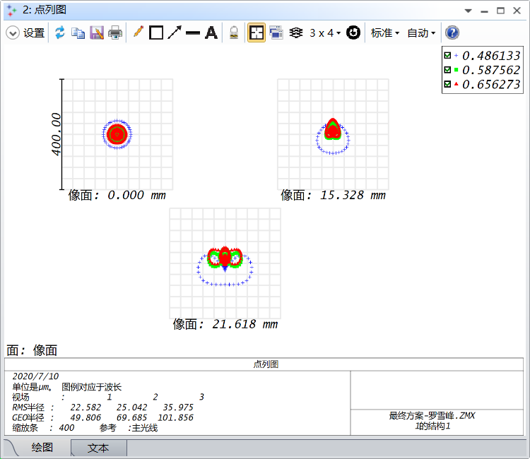

图5 全视场三个视场1.5m时的点列图

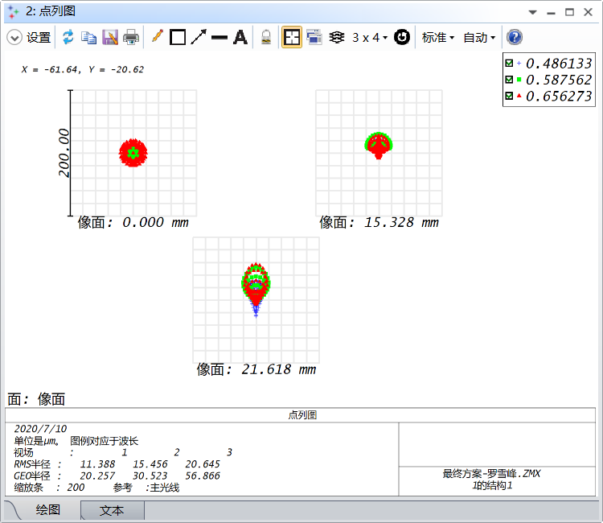

图6 F3.5三个视场1.5m时的点列图

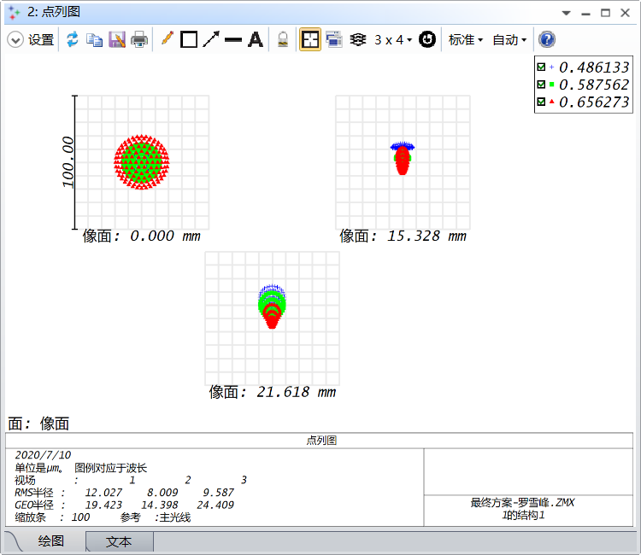

图7 F8三个视场1.5m时的点列图

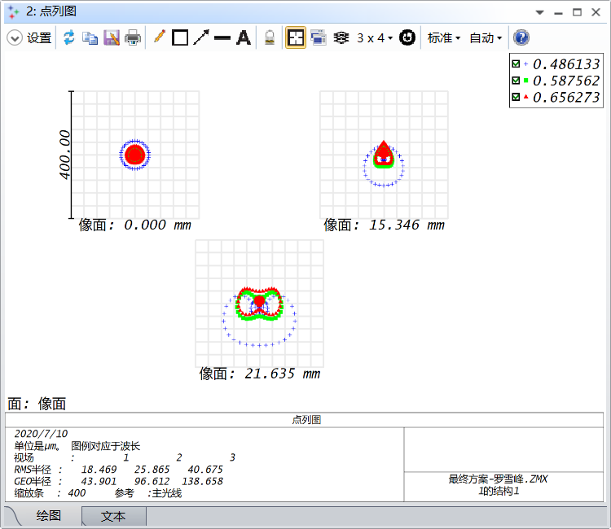

图8 全孔径三个视场5m时的点列图

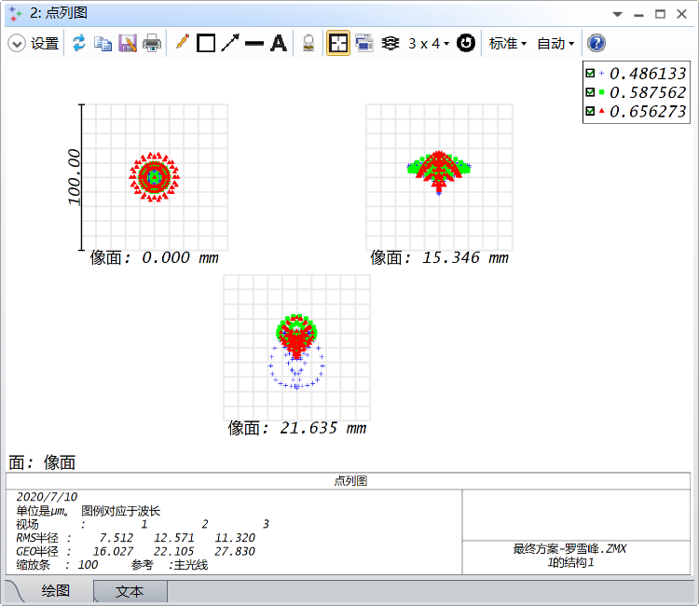

图9 F3.5三个视场5m时的点列图

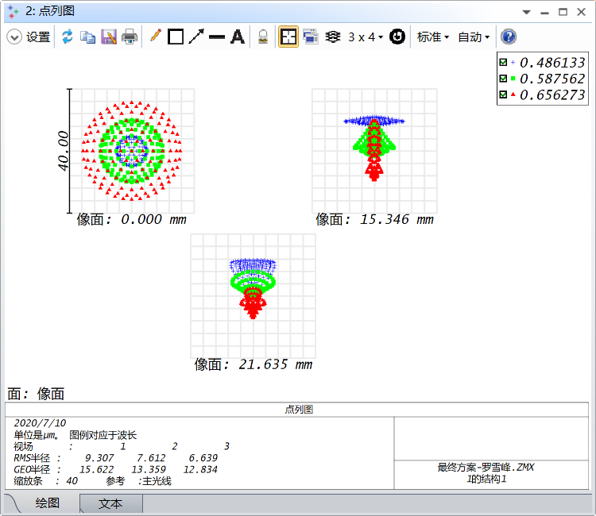

图10 F8三个视场5m时的点列图

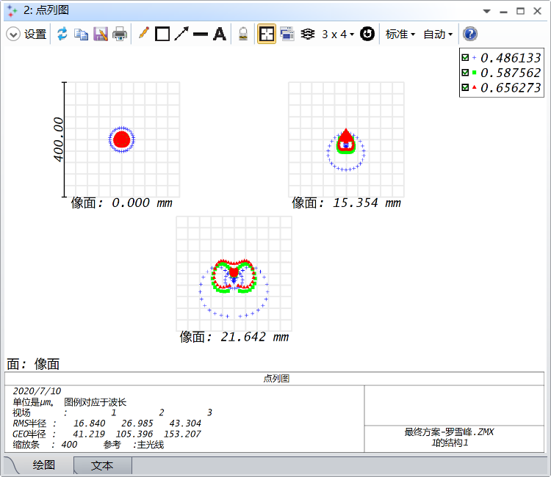

图11 图7 全视场三个视场20m时的点列图

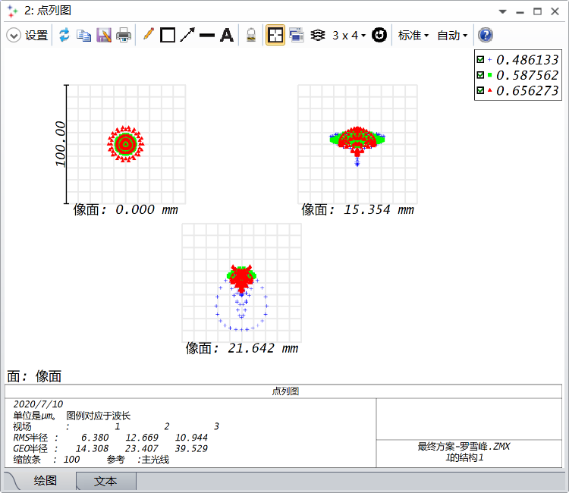

图12 F3.5三个视场20m时的点列图

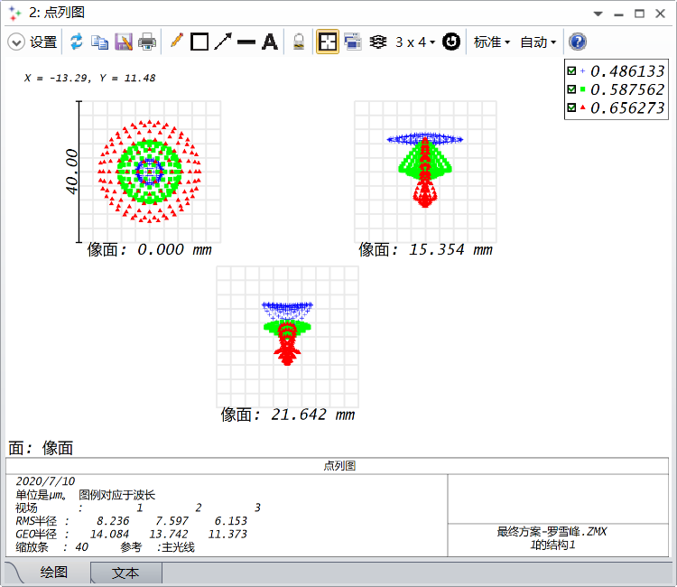

图13 F8三个视场20m时的点列图

三个摄影距离时混合色光的MTF曲线：

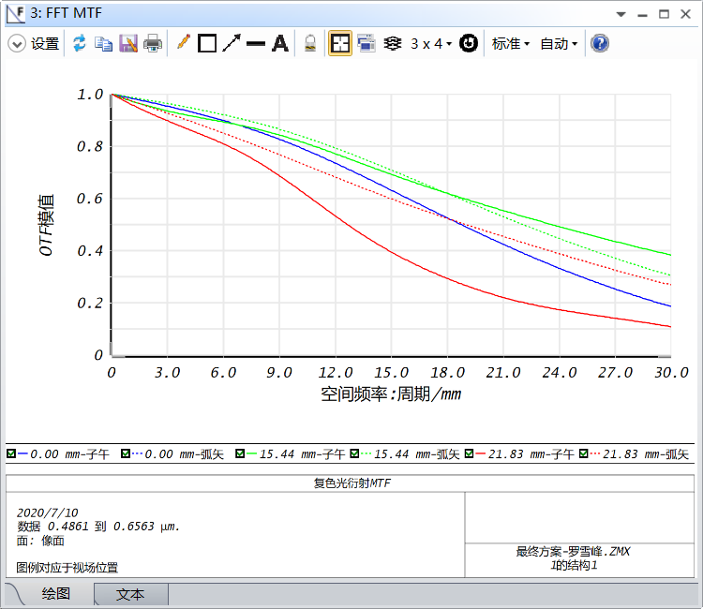

图14 1.5m时的全孔径的MTF曲线

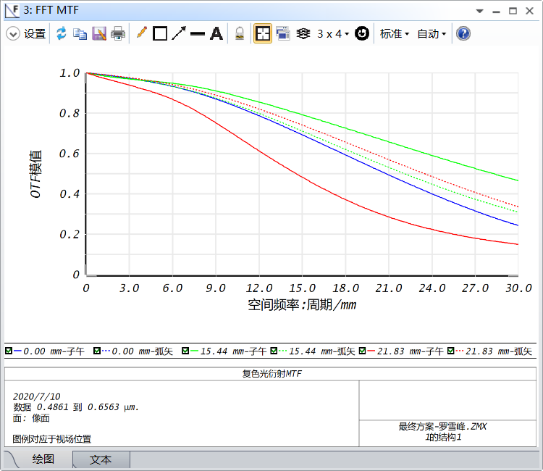

图15 1.5m时的F3.5的MTF曲线

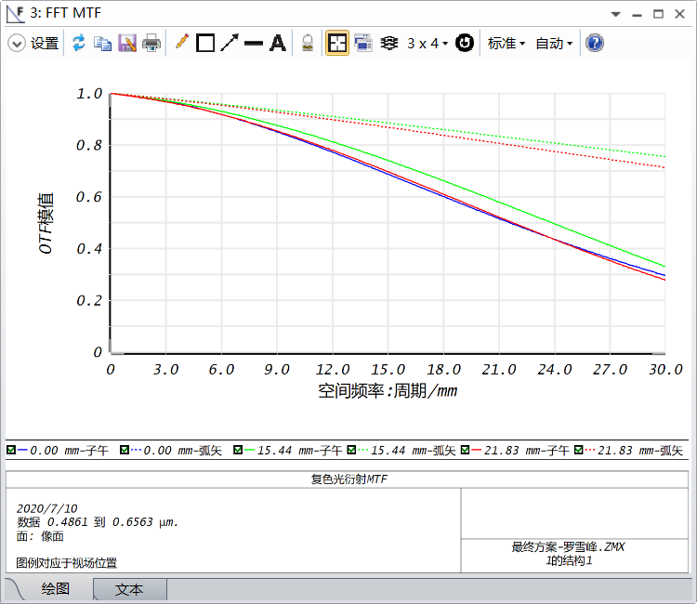

图16 1.5m时的F8的MTF曲线

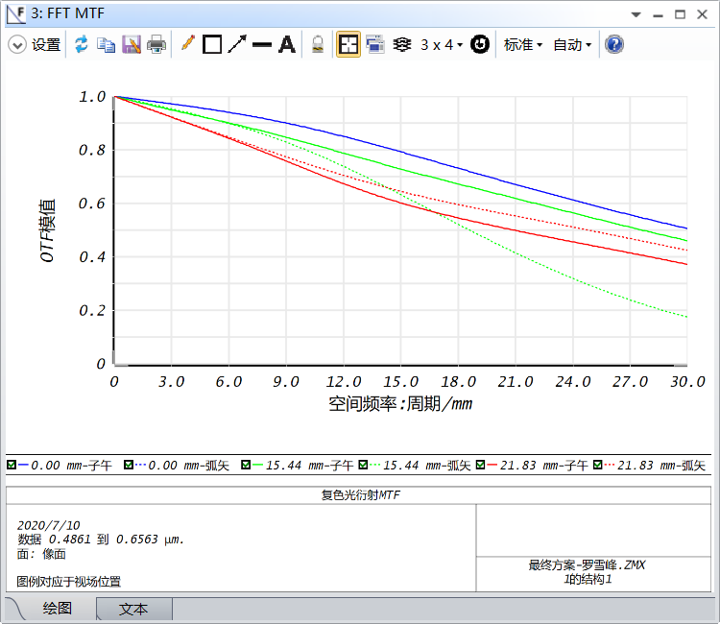

图17 5m时的全视场的MTF曲线

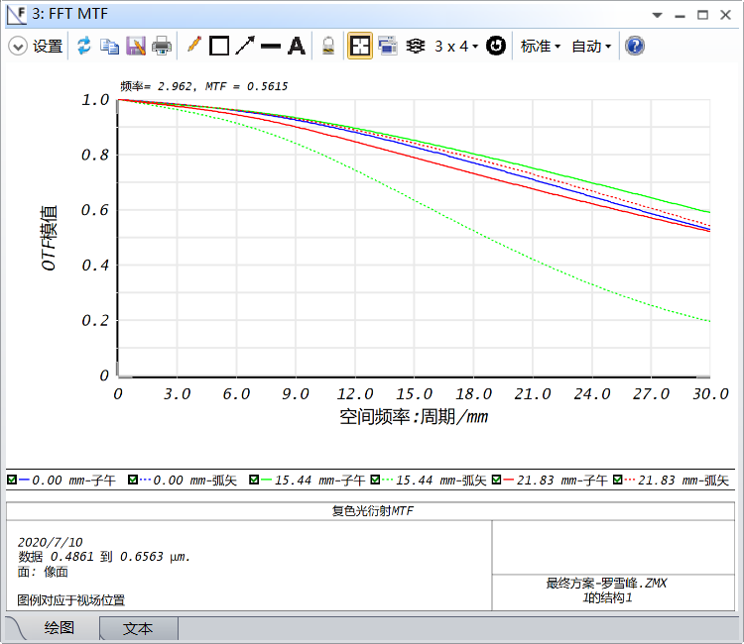

图18 5m时F3.5的MTF曲线

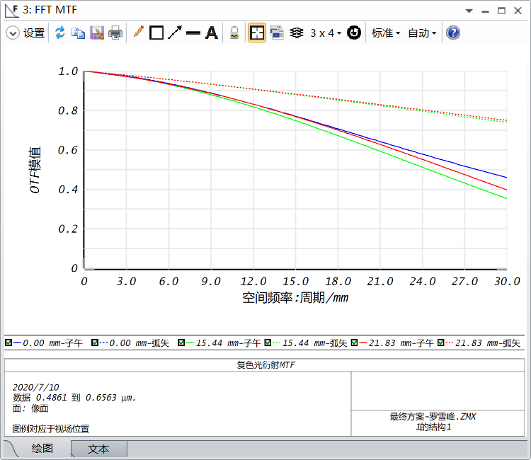

图19 5m时的F8的MTF曲线

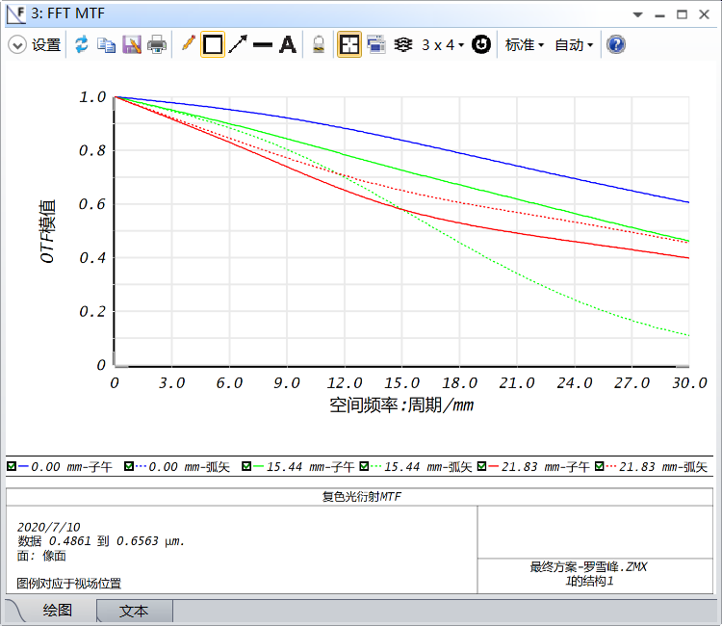

图20 20m时的全视场的MTF曲线

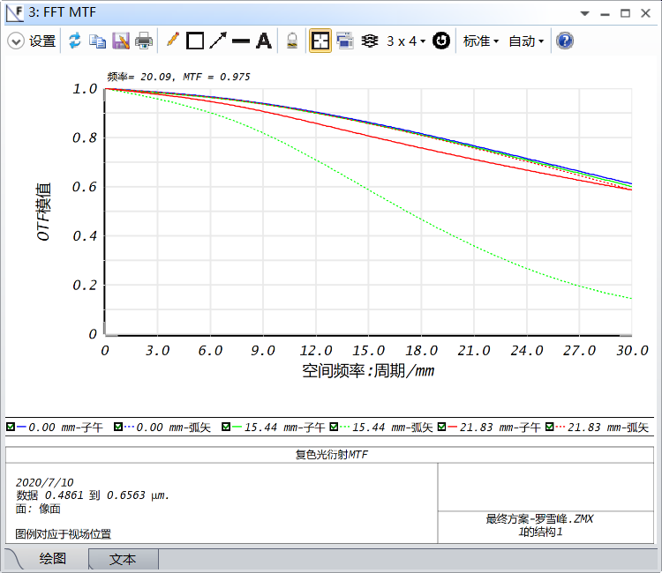

图21 20m时的F3.5的MTF曲线

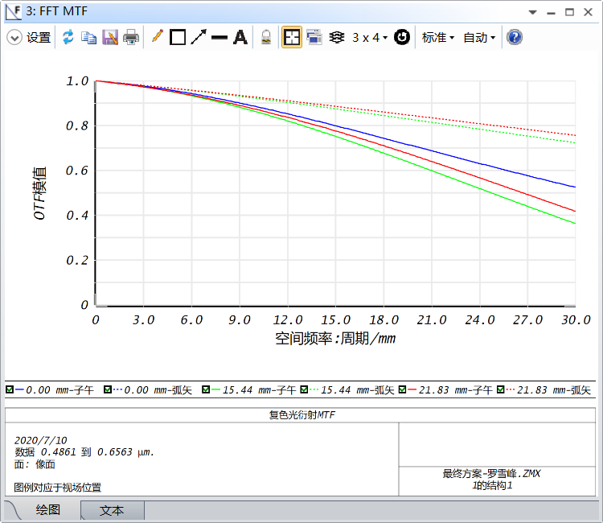

图22 20m时的F8的MTF曲线

规定的5m摄影距离时需达到Ⅰ级照相镜头的MTF标准：

|  |  |  |  |  |
| --- | --- | --- | --- | --- |
| 特征频率  孔径 | 10lp/mm | | 30lp/mm | |
| 轴上点 | 0.707视场 | 轴上点 | 0.707视场 |
| 全孔径 | 0.6 | 0.3 | 0.3 | 0.15 |
| F8时 | 0.75 | 0.4 | 0.4 | 0.2 |

设计透镜所达到的5m摄影距离达到的MTF值：

|  |  |  |  |  |
| --- | --- | --- | --- | --- |
| 特征频率  孔径 | 10lp/mm | | 30lp/mm | |
| 轴上点 | 0.707视场 | 轴上点 | 0.707视场 |
| 全孔径 | 0.884521 | 0.800946 | 0.505860 | 0.174647 |
| F8时 | 0.870283 | 0.860347 | 0.460492 | 0.353356 |

**镜头数据**

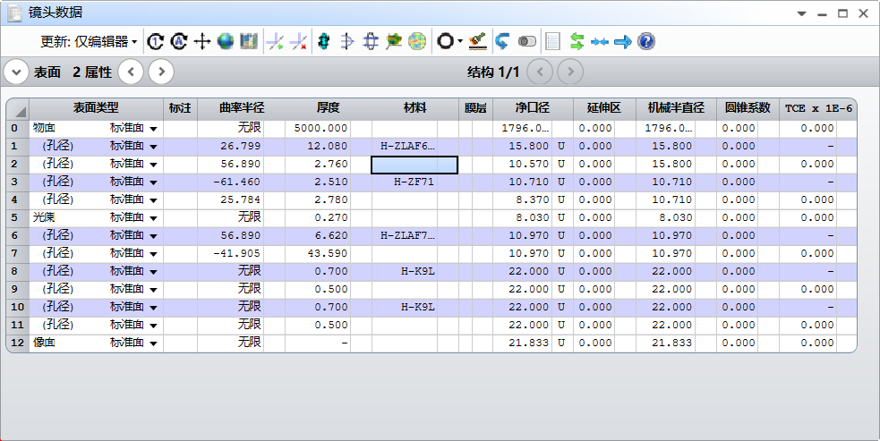

图23 镜头数据

系统/详细数据

文件 : F:\ZJU\光学系统设计\搞事\最终方案-罗雪峰.ZMX

题目:

日期 : 2020/7/10

常用透镜数据:

面 : 12

光阑 : 5

系统孔径 : 光阑尺寸浮动 = 8.03

半口径快速计算 : on

视场无偏振 : On

将膜层相位转化为等效几何光线 : On

J/E 转化方法 : X轴参考

玻璃库 : CDGM-ZEMAX201904

光线瞄准 : 近轴参考, 缓存 开

自动计算光瞳漂移 : On

X 光瞳位移 : 0

Y 光瞳位移 : 0

Z 光瞳位移 : 0.2908826

X 光瞳压缩 : 0

Y 光瞳压缩 : 0

切趾法 : 均匀,因子 = 0.00000E+00

OPD参考 : 出瞳

近轴光线 : 忽略坐标断点

F/#计算 : 追迹光线

惠更斯积分计算 : 自动

显示坐标断点 : on

多线程 : on

OPD以2π取模 : off

温度 (℃) : 2.00000E+01

压强 (ATM) : 1.00000E+00

折射率数据与环境匹配 : off

有效焦距 : 60.13689 (在系统温度和压强的空气中)

有效焦距 : 60.13689 (在像方空间)

后焦距 : 0.0195817

总长 : 73.01013

像方空间 F/# : 2.799502

近轴处理 F/# : 2.841168

工作F/# : 2.883993

像方空间 NA : 0.1733205

物方空间 NA : 0.00213924

光阑半径 : 8.03

近轴成像高度 : 21.833

近轴放大率 : -0.01215591

入瞳直径 : 21.48128

入瞳位置 : 20.76256

出瞳直径 : 17.54465

出瞳位置 : -49.59667

视场类型 : 近轴像高（毫米）

最大径向视场 : 21.833

主波长 : 0.5875618 μm

角放大率 : 1.224378

透镜单位 : 毫米

光源单位 : 瓦特

分析单位 : 瓦特/cm^2

无焦模式单位 : 毫弧度

MTF 单位 : 周期/毫米

注：以上所有数据均为开启近轴光线瞄准下得出。